Nepal College of information Technology
Imado lalitpur
Assessment Exam Spring Semester 2007

Program : ELX/IT/CE Semester: Spring
Time : 3hrs Year : 2007
Engineering Math-IV

1 a) State and prove Cauchy's integral formula and use it to find 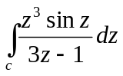 where C is the unit circle counterclockwise. 8
b) Show that 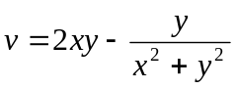 is harmonic function. Find harmonic conjugate u of v. 7
2. a) Evaluate 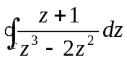 where c is the unit circle. 5
b) Find the maclaurin series of the function 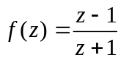 5
OR
Find the Laurent's series for 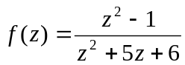 in the region 2<|z|<3.
c) Determine the location and order of the zeros of f(z) = tanπz 5
3. a) Determine the location and type of singularity of f(z) = (z² + a²)⁻² 5
b) Find Z- transform of 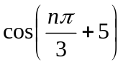 5
c) Show that 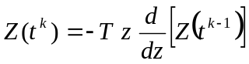 5
4. a) Find the inverse Z-transform of 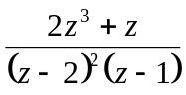 7
b Solve: 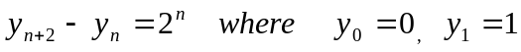 8
5. a) If F (z) and G(z) are respectively the z-transform of f(t) and g(t) then prove that Z 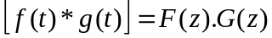 7
Or
Find Z (i^{-eat}) and hence deduce the values of Z ( cos at) and z (sin at). 7
b) Find fourier Sine and Cosine transform of 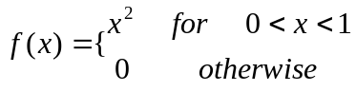 8
6. a) Find fourier transform of f(x) = 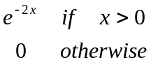 7

b) Show that 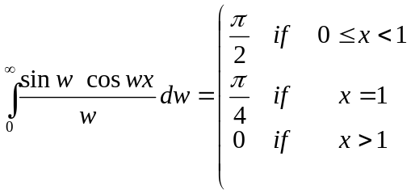 8
7. Attempt all:- 2*5
a) Express the function f(z)= e^{z} in the form of u+iv
b) Find the derivative of f(z)=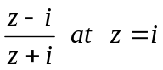
c) Prove Z(a^{n})= 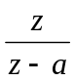
d) State and prove linearity property of Z-transform i.e Z[a f(t) +bg(t)] = aZ {f(t)} + bZ {g(t)}
e) Verify u =e^{x} siny satisfies two dimensional Laplace equation.

